Incremental refresh
This is to present how Google Analytics table has been set up for incremental refresh. The table refreshes incrementally daily to reflect the nature of the live data streaming.
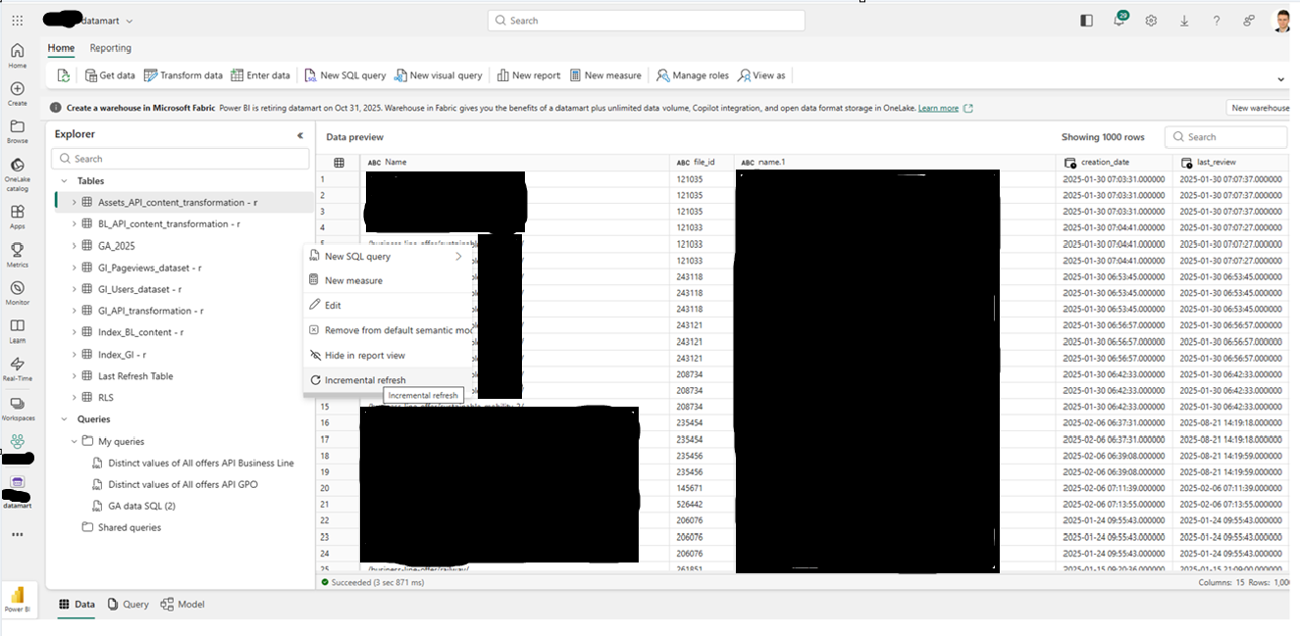
Datamart refresh setup
The refresh for other tables ex. APIs has been set daily.
